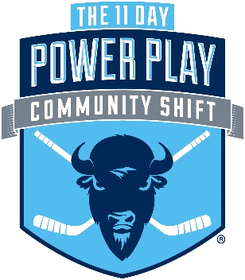

Yes, that is right. I was am participating in the 2023 11 Day Power Play Community Shift, an 11-day marathon hockey game that raises money for cancer research and wellness programs, because it’s my promise to help cancer patients. I won’t go back on that promise.
Donations raised will benefit cutting-edge cancer research and wellness programs at Roswell Park, Camp Good Days, Make-A-Wish Western New York and The Roswell Park and Oishei Children’s Cancer and Blood Disorders Program. In the past six years, The 11 Day Power Play has raised more than $8.4 million for cancer causes in our community.

[PERSONAL MESSAGE or playing in honor of statement].

I have set a personal goal of [$500], and I am intent on exceeding it! Please consider making a donation today. No donation is too small, and every dollar adds up to something greater than any one of us could accomplish alone. To donate, visit my fundraising page at https://communityshift.11daypowerplay.com/. Include a note directing your 100% tax deductible donation towards my goal.

Together, we can continue to make an impact in the search for a cure, and better the lives of those living with cancer. Thank you for supporting me!

Sincerely,
Fundraiser-First-Name

If you would like to find out more about this event, check us out at 11daypowerplay.com. Follow us on Instagram, Facebook, Twitter and Youtube

